**WEEK – 5**

**MICROSERVICES :**

**MicroServices with API Gateway :**

**Creating Microservices for account and loan :**

In this hands on exercises, we will create two microservices for a bank. One microservice for handing accounts and one for handling loans. Each microservice will be a specific independent Spring RESTful Webservice maven project having it's own pom.xml. The only difference is that, instead of having both account and loan as a single application, it is split into two different applications. These webservices will be a simple service without any backend connectivity. Follow steps below to implement the two microservices

**Account Microservice :**

* Create folder with employee id in D: drive
* Create folder named 'microservices' in the new folder created in previous step. This folder will contain all the sample projects that we will create for learning microservices. • Open https://start.spring.io/ in browser • Enter form field values as specified below:

**o** Group: com.cognizant **o** Artifact: account

* Select the following modules o Developer Tools > Spring Boot DevTools o Web > Spring Web • Click generate and download the zip file
* Extract 'account' folder from the zip and place this folder in the 'microservices' folder created earlier
* Open command prompt in account folder and build using mvn clean package command • Import this project in Eclipse and implement a controller method for getting account details based on account number. Refer specification below:

**o** Method: GET **o** Endpoint: /accounts/{number} **o** Sample Response.

Just a dummy response without any backend connectivity.

{ number: "00987987973432", type: "savings", balance: 234343 }

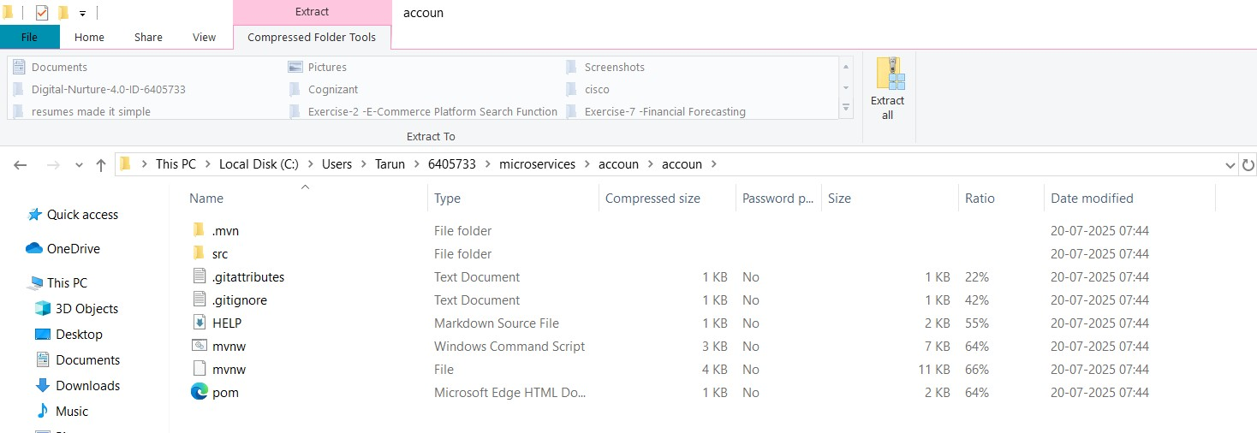

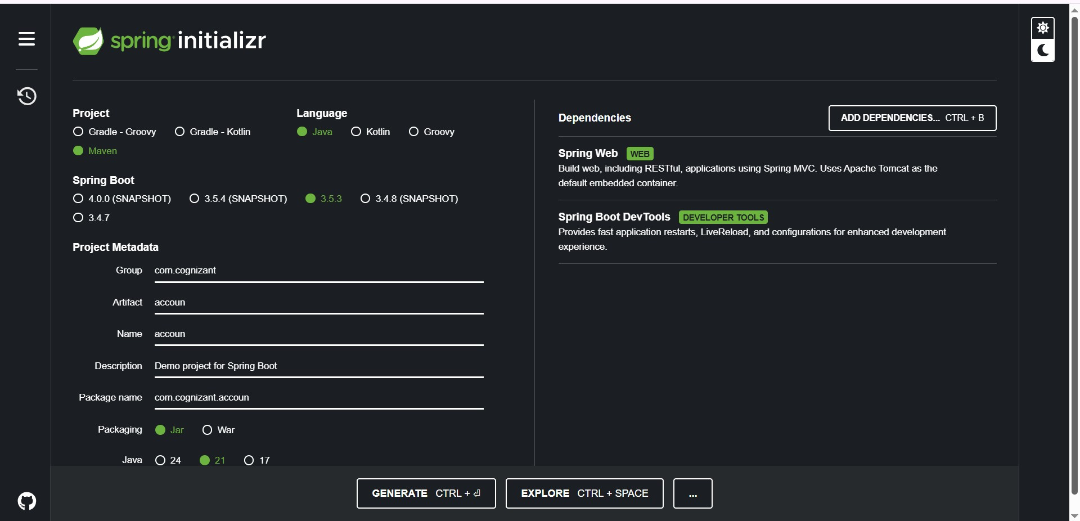

**AccounApplication.java**

package com.cognizant.accoun;

import org.springframework.boot.SpringApplication; import org.springframework.boot.autoconfigure.SpringBootApplication;

@SpringBootApplication public class AccounApplication { public static void main(String[] args) {

SpringApplication.*run*(AccounApplication.class, args);

}

}

**AccounController.java**

package com.cognizant.accoun.controller; import org.springframework.web.bind.annotation.*;

@RestController

@RequestMapping("/accounts") public class AccounController {

@GetMapping("/{number}")

public Account getAccount(@PathVariable String number) { return new Account(number, "savings", 234343);

}

static class Account { private String number; private String type; private double balance;

public Account(String number, String type, double balance) {

this.number = number;

this.type = type;

this.balance = balance;

}

public String getNumber() { return number; } public String getType() { return type; }

public double getBalance() { return balance; }

}

}

**pom.xml**

<?xml version="1.0" encoding="UTF-8"?>

<project xmlns="http://maven.apache.org/POM/4.0.0" xmlns:xsi="http://www.w3.org/2001/XMLSchema-instance" xsi:schemaLocation="http://maven.apache.org/POM/4.0.0 https://maven.apache.org/xsd/maven-4.0.0.xsd"> <modelVersion>4.0.0</modelVersion>

<parent>

<groupId>org.springframework.boot</groupId>

<artifactId>spring-boot-starter-parent</artifactId>

<version>3.5.3</version>

<relativePath/> <!-- lookup parent from repository --> </parent>

<groupId>com.cognizant</groupId>

<artifactId>accoun</artifactId>

<version>0.0.1-SNAPSHOT</version>

<name>accoun</name>

<description>Demo project for Spring Boot</description> <url/>

<licenses>

<license/>

</licenses>

<developers>

<developer/>

</developers>

<scm>

<connection/>

<developerConnection/>

<tag/>

<url/>

</scm>

<properties>

<java.version>24</java.version>

</properties>

<dependencies>

<dependency>

<groupId>org.springframework.boot</groupId>

<artifactId>spring-boot-starter-web</artifactId>

</dependency>

<dependency>

<groupId>org.springframework.boot</groupId>

<artifactId>spring-boot-devtools</artifactId>

<scope>runtime</scope>

<optional>true</optional>

</dependency>

<dependency>

<groupId>org.springframework.boot</groupId>

<artifactId>spring-boot-starter-test</artifactId>

<scope>test</scope>

</dependency>

</dependencies>

<build>

**OUTPUT :**

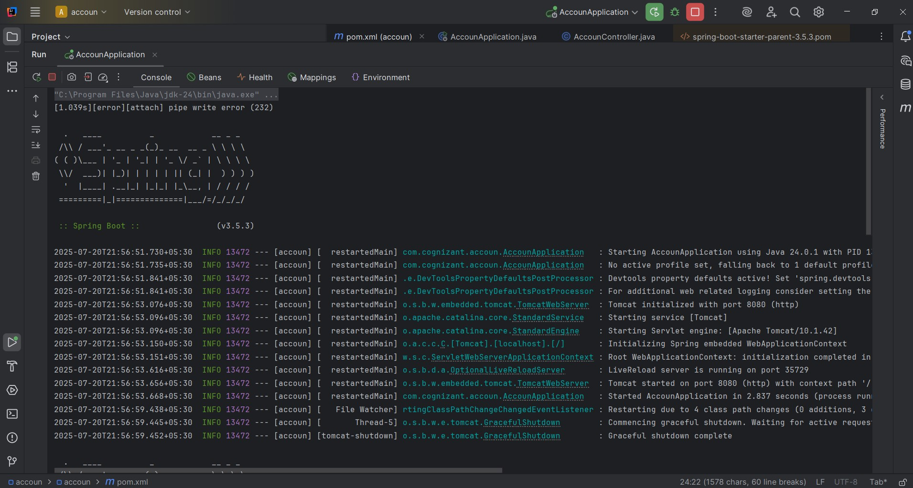

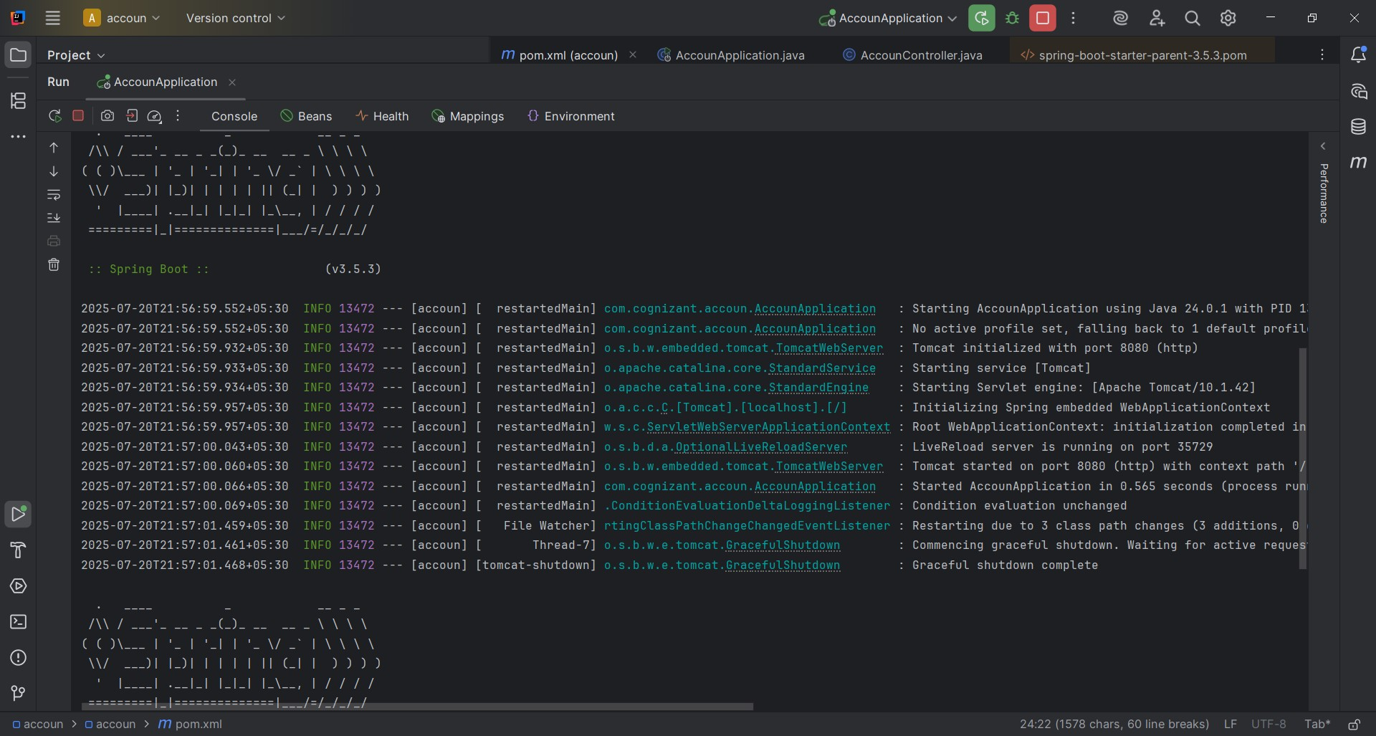

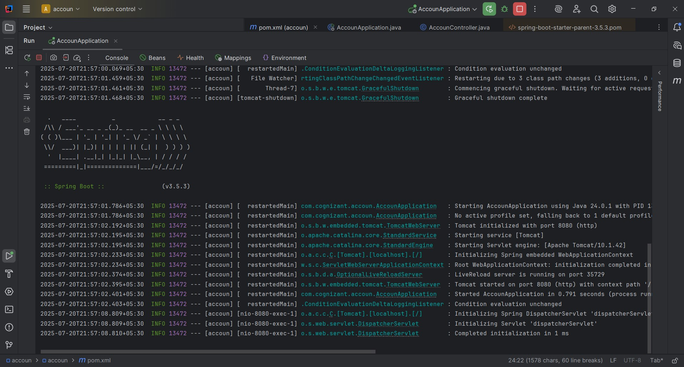

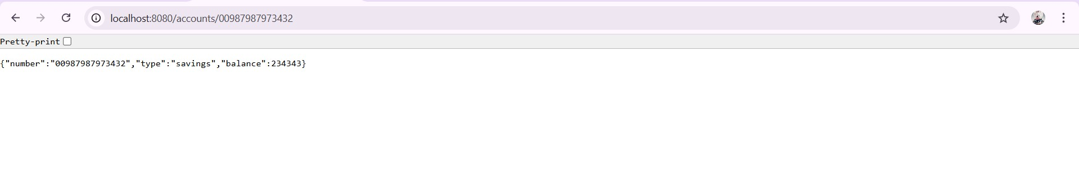

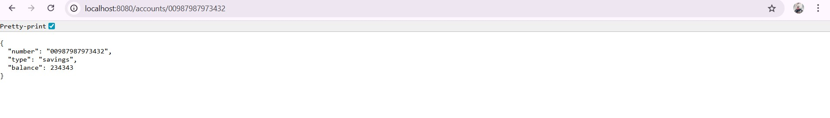

**Loan Microservice :**

Follow similar steps specified for Account Microservice and implement a service API to get loan account details **o** Method: GET **o** Endpoint: /loans/{number} **o** Sample Response.

Just a dummy response without any backend connectivity.

{ number: "H00987987972342", type: "car", loan: 400000, emi: 3258, tenure: 18 }

* Launching this application by having account service already running
* This launch will fail with error that the bind address is already in use
* The reason is that each one of the service is launched with default port number as 8080. Account service is already using this port and it is not available for loan service.
* Include "server.port" property with value 8081 and try launching the application
* Test the service with 8081 port Now we have two microservices running on different ports. NOTE: The console window of Eclipse will have both the service console running. To switch between different consoles use the monitor icon within the console view.

**LoanController.java :**

package com.cognizant.loan.controller; import org.springframework.web.bind.annotation.*;

@RestController

@RequestMapping("/loans") public class LoanController {

@GetMapping("/{number}") public Loan getLoan(@PathVariable String number) { return new Loan(number, "car", 400000, 3258, 18);

}

static class Loan { private String number; private String type; private double loan; private double emi; private int tenure;

public Loan(String number, String type, double loan, double emi, int tenure) { this.number = number;

this.type = type; this.loan = loan; this.emi = emi;

this.tenure = tenure;

}

public String getNumber() { return number; } public String getType() { return type; } public double getLoan() { return loan; } public double getEmi() { return emi; } public int getTenure() { return tenure; } }

}

**LoanApplication.java :**

package com.cognizant.loan;

import org.springframework.boot.SpringApplication; import org.springframework.boot.autoconfigure.SpringBootApplication;

@SpringBootApplication public class LoanApplication { public static void main(String[] args) {

SpringApplication.*run*(LoanApplication.class, args);

}

}

**application.properties :**

server.port=8081

spring.application.name=loan

**OUTPUT :**

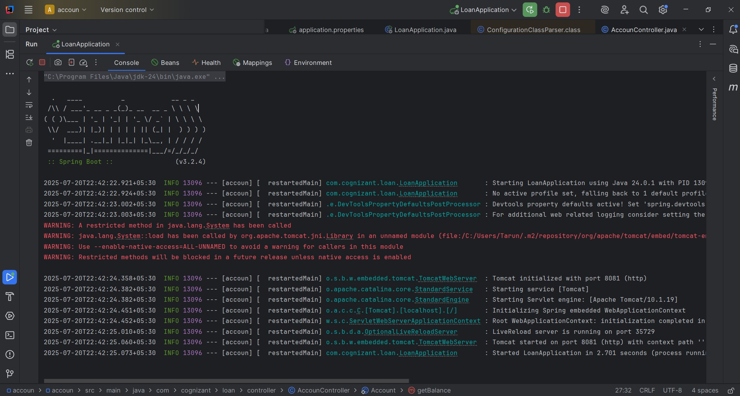



{

"number": "H00987987972342",

"type": "car",

"loan": 400000,

"emi": 3258,

"tenure": 18

}

**_____________________________________________________________________________________________________________**